Description

7 Days /6 Nights
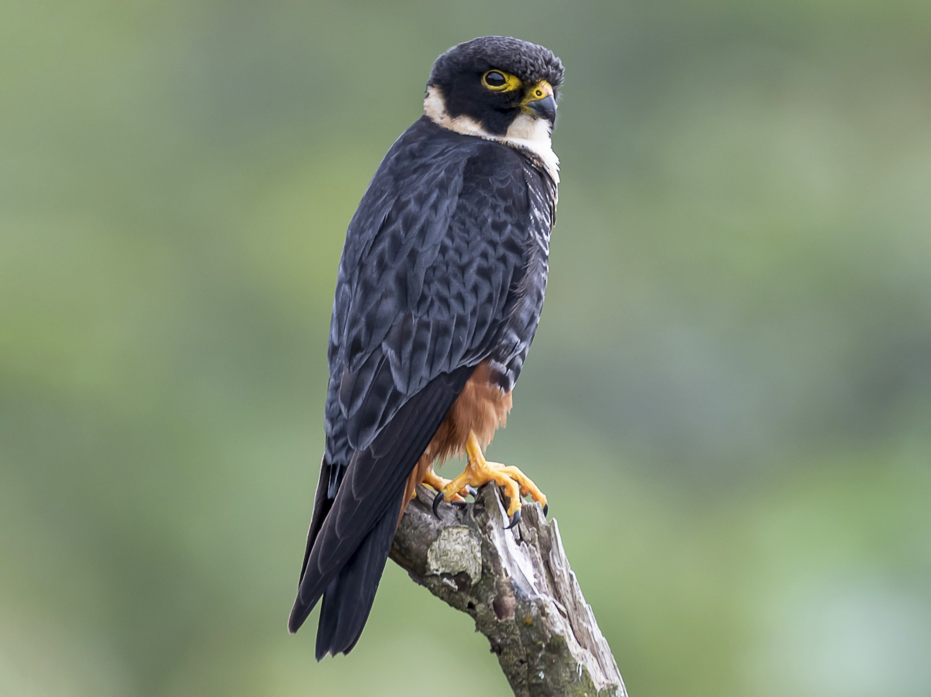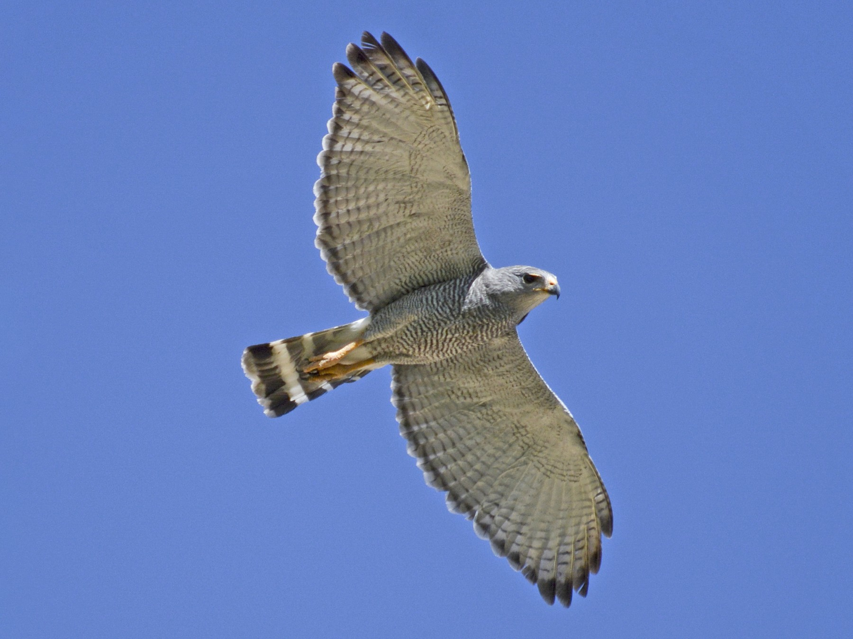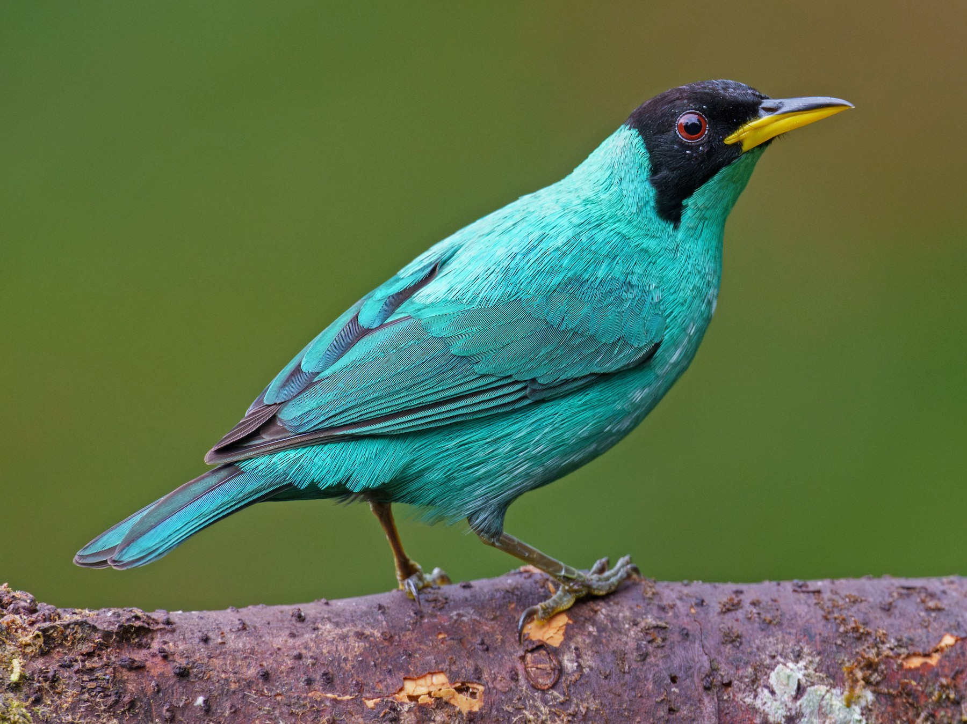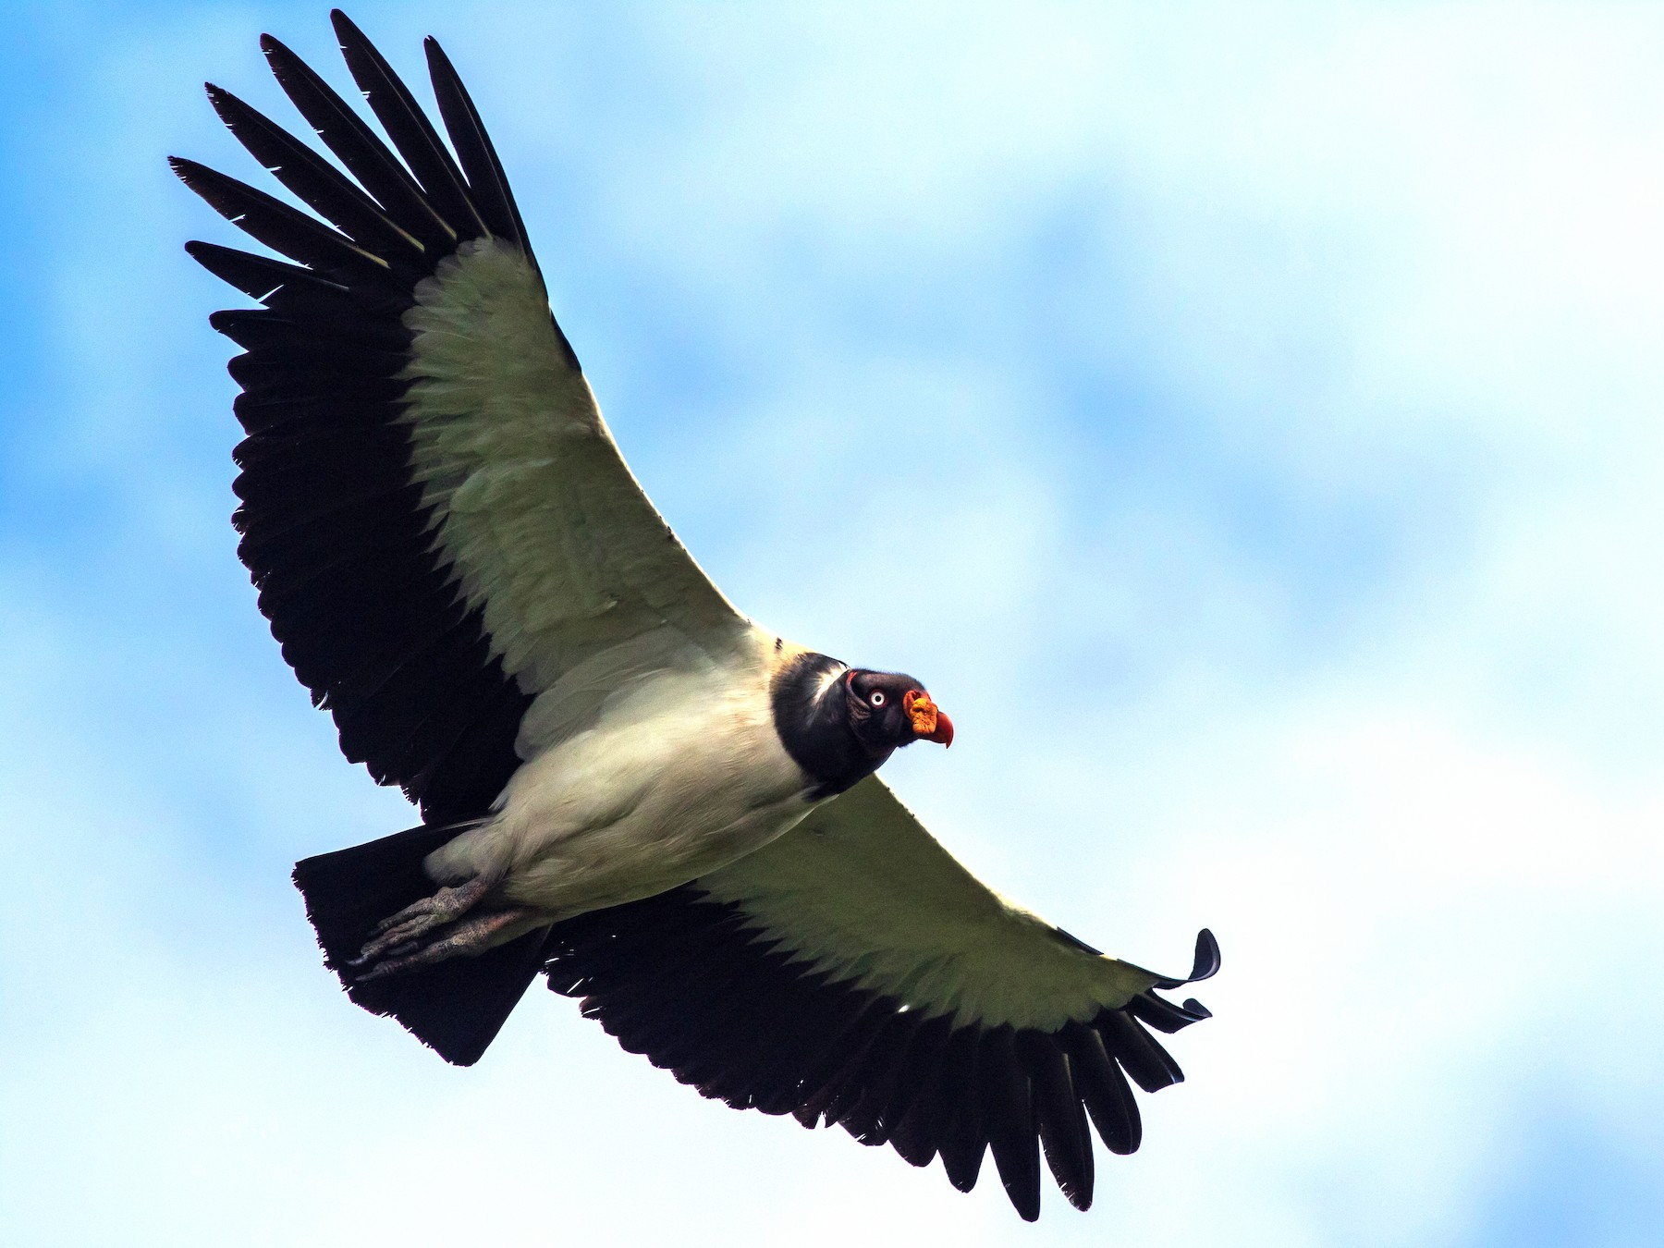

Discover the Transformative Power of Nature: A Birdwatching Experience in Boca Tapada.
Boca Tapada in Costa Rica is nothing short of a dream come true. This secluded sanctuary, nestled in the heart of the northern lowlands, boasts an unparalleled variety of avian species, making it a must-visit destination for those passionate about birding.
Step into a world alive with the vibrant colors of toucans, the graceful flight of king vultures, and the elusive beauty of the resplendent quetzal. With over 400 recorded species, including rare and endemic birds, Boca Tapada offers an unforgettable experience for those who seek both adventure and precision in their observations.
Our carefully curated birdwatching tour is designed for specialists who value the diversity of species and the tranquillity and intimacy of the environment. Here, the symphony of nature and the thrill of spotting your next life come together to create a transformative outdoor experience.
Join us in Boca Tapada to immerse yourself in the rhythms of the wild, refine your birding expertise, and rediscover the joy of connecting with the avian wonders of Costa Rica.

Highlights:
- Immerse yourself in serene birdwatching experiences, with over 350 species creating a symphony of nature.
- Relax on a tranquil boat tour along the San Carlos River, surrounded by pristine landscapes and vibrant wildlife.
- Capture stunning images of tropical birds and wildlife in specialized photography setups amidst natural backdrops.
- Escape into the lush rainforest on guided hikes, discovering untouched flora and fauna in a peaceful setting.
- Rejuvenate at eco-friendly lodges, where the sounds of nature and tranquil surroundings ensure ultimate relaxation.
- Connect with the natural world through adventurous activities that invigorate the soul and provide a refreshing escape.

Day 1: Fly to San Jose, Costa Rica Aprox. (20 KM)
Welcome to Costa Rica. Upon your arrival, a representative from our agency will greet you at the airport and provide a detailed explanation of the selected itinerary. Additionally, you will receive the welcome information, and the representative will accompany you and the rest of the group to your hotel in Heredia.

Included Today
- Accommodation Hotel Bougainvillea, Standard Mountain View Room
- Private Airport Transfer.

Day 2: Heredia – Boca Tapada Aprox (140 KM)

After breakfast, the guide and driver will pick you up at your hotel in Heredia to begin the journey to the northern part of Costa Rica. On the way, you will enjoy beautiful landscapes before arriving at Boca Tapada, one of the most renowned areas for bird watching, thanks to its rich biodiversity. During the visit, it will be possible to observe the King Vulture, one of the most emblematic birds of the region. Boca Tapada de San Carlos offers a unique immersion in nature. Its lush trails within the tropical rainforest allow a direct connection with the natural environment. With over 150 species of trees, plus monkeys, caimans, coatis and red frogs, as well as the symphony of 350 species of birds, this place is a paradise for birdwatchers and photographers. Laguna del Lagarto Lodge, covering 500 protected hectares, offers various options for exploration, whether on foot, horseback or by boat, with each excursion leaving a memorable impression. For your comfort, all our rooms are air conditioned.

Included Today
- Accommodation Laguna del Lagarto Ecolodge, Standar Room.
- Breakfast
- Sunset Birdwatching Hike.
- Dinner

Day 3: Boca Tapada

Before breakfast, the group will go on a bird-watching walk around the hotel grounds, guided by a naturalist. Afterwards, you will enjoy a delicious breakfast and depart on a three-hour tour of the San Carlos River, accompanied by the local boatman. During the trip, you will be able to observe crocodiles, basilisk lizards, turtles and various aquatic birds. The boat will sail to the Nicaraguan border, where you can explore the picturesque village of Boca San Carlos and admire the majestic San Juan River and the Indio Maiz Reserve. Upon return, you will enjoy dinner at the lodge.

Included Today
- Accommodation Laguna del Lagarto Ecolodge, Standar Room.
- Breakfast
- Sunrise Birdwatching Walk
- Boat Trip at San Carlos River
- Dinner

Day 4: Boca Tapada

You will begin your day with a delicious breakfast before embarking on an approximately 2-hour tour of 10 km of trails in the reserve, led by our naturalist guide. Throughout the tour, you will explore the flora and fauna of the majestic rainforest in its natural state, spotting if you are lucky: poison dart frogs, bullet ants, monkeys, tapir tracks, ancient trees and other wonders. You will be provided with rubber boots and a walking stick, but we recommend you bring insect repellent, rain gear, water, camera and binoculars to make the most of the experience.

Included Today
- Accommodation Laguna del Lagarto Ecolodge, Standar Room.
- Breakfast
- Hiking Forest tour
- Dinner

Day 5: Boca Tapada
After breakfast, participants will go on a photography tour on specially designed platforms that can accommodate up to eight photographers. From there, they will have the opportunity to capture images of a wide variety of birds such as toucans, oropendolas, parakeets, honeycreepers, tanagers, woodpeckers and many more, from no more than four meters away against natural backdrops. In addition, there are exclusive hiding places for photographing the King Vulture and bats, as well as a special garden for hummingbird watching.

Included Today
- Accommodation Laguna del Lagarto Ecolodge, Standar Room.
- Breakfast
- Sunrise Birdwatching Walk
- King Vulture Hide Photography
- Dinner

Day 6: Boca Tapada
The group will start the day early with an early morning bird-watching walk, guided by an expert, before breakfast. During this activity, if you are lucky, you will be able to observe a variety of local birds, enjoying the natural beauty of the area on your last day in Boca Tapada. At the end of the day, you will enjoy dinner in a cozy atmosphere.

Included Today
- Accommodation Laguna del Lagarto Ecolodge, Standar Room.
- Breakfast
- Sunrise Birdwatching Walk
- Dinner
Day 7: Boca Tapada – San José Airport
Today is the group's last day in the country. You will start with a morning bird watching walk before breakfast to make the most of your time in nature. We hope you have enjoyed the trip and had the opportunity to observe a wide variety of birds in their natural environment. The transfer will then depart Boca Tapada for the airport in the morning hours, bringing your memorable visit to an end.
- Breakfast
- Sunrise Birdwatching Walk
Included in the tour rates

- Transfers and transportation in air-conditioned buses with driver.
We use the following bus types:
7 – 15 Pax: Microbus with 19 – 22 seats
16 – 24 Pax: Microbus with 33 – 40 seats
25 – 35 Pax: Microbus with 42 seats

- Accommodation at the hotels mentioned in the program in rooms with private bathroom
- Meals as per description
- Excursions with English speaking guides as listed under “Included today”
- Travel documentation upon arrival

Not Included
- Voluntary tips
- Airport departure tax in San José, US$ 29.00 per person (mostly included in the airline ticket)
- Optional activities
- Personal expenses

Important - If National Park entrance fees are included, we need not only the names of the clients, but also their passport number and nationality at the time of booking or, in the case of groups, at the time of receiving the list of participants! - Prices per person according to the selected room. As a rule, the triple room (regardless of whether adults or children are sharing) is offered in one of the following bed configurations: ▪ 1 double bed + 1 single bed, ▪ 1 double bed + 1 extra bed (rollaway or sofabed) ▪ 2 double bed

Price 2025
Pax | Price in Cad per Pax
10 - 14 Pax + 1 TL free | 2415
15-19 Pax + 1 TL Free | 2235
20 Pax + 1 TL Free | 2040
Single Room | 350
Triple Reduction | 90

Rates not available for Easter Week: 06.04.2025 – 13.04.2025

Reservations/Allotments
No reservations or allocations have been made so far. This offer is valid subject to availability at the hotels mentioned in the program at the moment of receiving your order to book or block the rooms.

Payment Conditions
If no other written conditions have been negotiated for this offer, the following payment conditions apply:
Groups (7 or more persons) A deposit of 30% must be paid 45 days prior to arrival. The rest is due 10 days prior to arrival. Some hotels and providers are asking for earlier payments. If this is the case, you will find all details under “comments” below

Comments:
Cancellation Policies If no other written conditions have been negotiated for this offer, the following cancellation policies apply. All cancellations must be in written. Hame Tours receives cancellations on working days only. If the cancellation has been sent on a Sunday or a public holiday, the next working day will count as cancellation day.

Groups (7 or more persons) After a definitive booking, cancellations up to 46 days before tour start will be billed with CAD$ 150.- service fee per order. Thereafter, the following fees for full or partial cancellations apply:
45-31 days before arrival: 10% of total sum
30-22 days before arrival: 20% of total sum
21-15 days before arrival: 30% of total sum
14-08 days before arrival: 50% of total sum
07-00 days before arrival or no show: 75% of total sum
If the group size is diminished due to a partial cancellation, resulting in a higher price, the new price will be billed.

Thank you very much for your request. We are happy to get your feedback on that offer soon.

